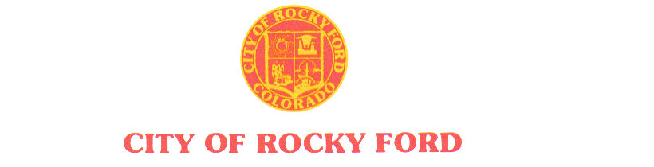

203 South Main * Rocky Ford, CO 81067 * (719) 254-7414 * Fax (719) 254-7416 ______________________________________________________________________

AGENDA

Regular City Council Meeting

Tuesday, July 9, 2019

*- The order and times of agenda items are approximate and intended as a guideline for the City Council –*

|  |  |
| --- | --- |
| Item # | Worksession – 6:00 PM |
| 1. | Chamber Agreement (Gobin Building) |
|  |  |
|  |  |
|  | **Recess** |
|  | Regular Council Session – 7:00 PM |
| 1. | Call to Order |
| 2. | Roll Call |
| 3. | Pledge of Allegiance |
| 4. | Approval of Minutes from June 26, 2019 Regular Meeting |
| 5. | Citizen Participation – 3-minute time limit  *Citizen participation is for items not otherwise on the agenda* |
| 6. | Approval of Agenda and Consent Agenda |
|  |  |
|  |  |
|  |  |
|  |  |
|  |  |
|  |  |
|  | Staff Reports |
|  |  |
|  |  |
|  | Mayor City Council Reports/updates |
|  | Citizen Participation – 3 minute time limit   1. *Citizen participation is for items not otherwise on the agenda* |
|  | 1. Items for Consideration at Future Meeting |
|  | *Departmental Reports; Gobin’s agreement (letter sent); School board work session* ***(JR look into)****; Review City Code (work sessions)****;*** *City Property sale; Employee Benefits;* |
|  | Adjournment |
|  |  |
|  |  |
|  |  |
|  |  |
|  |  |
|  |  |
|  |  |
|  |  |